

**Bangladesh University of Engineering & Technology**

**Department:** EEE

**Level/Term:** 4-2

**Course:** EEE 414

**Course Title:** Electrical Services Design

**Project:** Electrical Design of a Residential Building

**IDs:** 1806099, 1806101, 1806102, 1806105, 1806107, 1806125

**Names:**

Mahin Shahriar

Niaz Mahmud

Soumik Shanto

Ihzaz Abrar Sadik

Priya Acharjee

Arnab Nath

**Introduction**

The electrical design is equally important as the structural one while construction of a building, for safe, comfortable & efficient operation of the users. There are several rules, regulations & standards, both local & internationally recognized. A good design must maintain these. In our project, we have demonstrated the electrical design of such a residential building.

**Building Specifications**

The building as a reference we used was a ten-floor building, with a basement for accommodating the parking needs of the residents. Each floor consisted of two equally built units. There was a lift and other necessary features installed for convenience. The maximum length of the building is 67’-6” & maximum width is 50’-3”. The roof has necessary lightning protection installed for safety.

**Layouts**

**Basement**

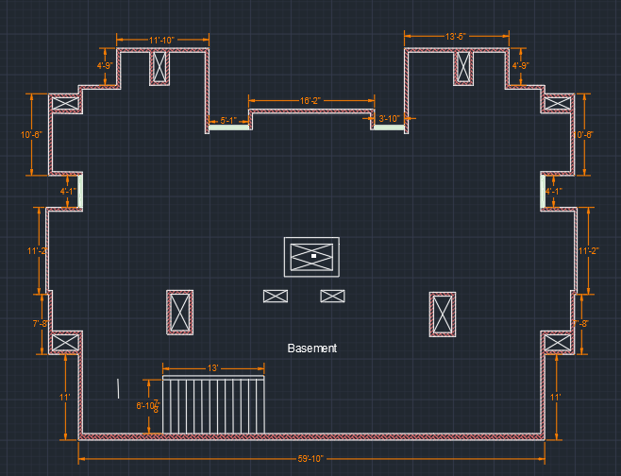

**Ground Floor**

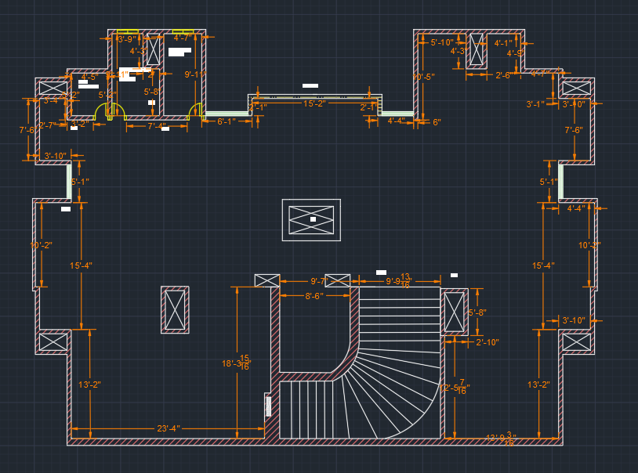

**Roof**

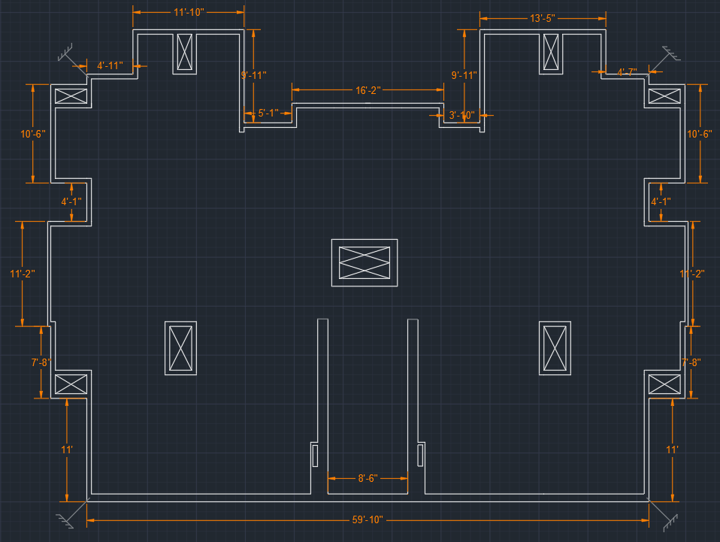

**First Floor**

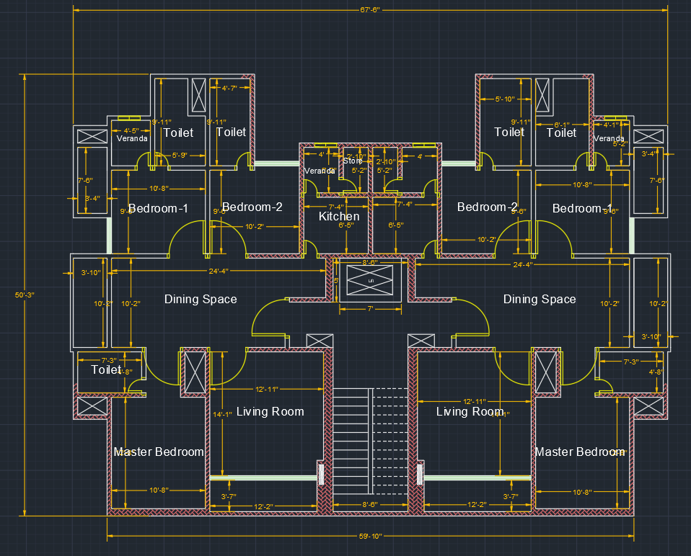

**Electrical Calculations**

**Master Bedroom:**

Area = 12’-8” x 10’-8”

= 135.111 ft2

= 12.5522 m2

Let, Standard Luminance of the bedroom = 150 lux

Loss factor, LLf = 0.9 (assumed)

Utilization factor = 0.5 (as the bulb will be connected to wall)

We will use a 15W bulb which has standard luminance of 1500 lux

So, Bulb needed = =

= 2.7893

So, we will use 2 pcs of 15W LED bulbs and 1 pc of 10W ceiling light bulbs.

Fan needed = = 1.3511

So, 1 fan is needed.

**Bedroom-2(upper left):**

Area = 10’-8” x 9’-6”

= 101.3365 ft2

= 9.4144 m2

Bulb needed = =

= 2.04

So, we will use 2 pcs of 15W LED bulb

Fan needed = = 1.01335

So, 1 fan is needed.

As per Master Bedroom 1, the circuit breaker of 15A is needed

**Bedroom-3(upper right):**

Area = 9’-6” x 10’

= 95 ft2

= 8.82579 m2

Bulb needed = =

= 1.9612

So, we will use 2 pcs of 15W LED bulb

Fan needed = = 0.95

So, 1 fan needed.

**Bedroom-4(Bottom-right):**

Area = 12’-10” x 14’

= 179.2 ft2

= 16.64 m2

#Bulb needed = =

= 3.69

So, we will use 3 pcs of 15W LED bulb and a 10W ceiling light.

Fan needed = = 1.792

So, 1 fan needed.

**Toilet:**

Area = 4’-8” x 7’-3’’

= 33.83 ft2

= 3.1429 m2

#Bulb needed = = [100 lux for toilet]

= 0.8730

So, we will use 1 pc of 10W LED (900 lumen)

Also 1 exhaust fan.

Bulb and Exhaust fan 🡪 100W

Hair Dryer,Heater + other safety factor 🡪 1000W

Total = 1100W

P = VI

* I = A = 5A

So, 5A circuit breaker with 1.5mm2 fuse.

**Kitchen:**

Area = 7’-4” x 6’-6’’

= 47.6645 ft2

= 4.428 m2

#Bulb needed = = [200 lux for toilet]

= 1.32

So, we will use 1 pc of 15W LED & 1 pc of ceiling bulb

**Stairs:**

Area = 8’-6” x 15’-6’’

= 131.755 ft2

= 12.2399 m2

#Bulb needed = = [100 lux for stairs][UF = 0.7]

= 2.1587

So, we will need 2 pcs of ceiling LED bulb

**Corridor:**

Area = 12’ x 3’-9’’

= 45 ft2

= 4.18 m2

#Bulb needed = = [100 lux for stairs][UF = 0.7]

= 1.03

So, we will need 1 pc of 10W LED bulb

**Drawing Room:**

Area = 24’ x 10”

= 240 ft2

= 22.2967 m2

#Bulb needed = = [150 lux for dinning table]

= 4.9548

So, we will need 5 pcs of 15W LED bulb

Fan needed = = 2.4

So, 2 fan needed.

**Ground Floor (SB Calc.)**

**For SB1**

F1 and L5 are used, L6 also used.

F1 🡪 100W

L5 🡪 15W

L6 🡪 15W

P = 130W.

I = A = 0.8441 A

So, 2x1.5 rm BYM + 1.5 BYA ECC are used.

**For SB2**

1x1.5 rm BYM + 1.5 BYA ECC are used.

**For SB3**

WL🡪 10W

CL 🡪 10W

EF 🡪 40W

P = (10+40+10+10+10+10+10) W.

= 100W

I = A = 0.6493 A

So, 2x1.5 rm BYM + 1.5 BYA ECC are used.

**For SB4:**

P = (5x10)W.

= 50W

I = A = 0.3246 A

So, 2x1.5 rm BYM + 1.5 BYA ECC are used.

**For SB5:**

P = (2x10) W.

= 120W

I = A = 0.77922 A

So, 2x1.5 rm BYM + 1.5 BYA ECC are used.

**Ground Floor (SDB Calc.)**

**For SDB:**

P = (130+100+50+120) W

= 400W

I = A = 2.597 A

So, 2x1.5 rm BYM + 1.5 BYA ECC are used.

**Ground Floor (Emergency Calc.)**

**For ESB1**

As L1 ,L2 are fluorescent LED

P = (15+15) = 30W

I = = 0.1948 A

So, 2x1.5 rm BYM + 1.5 BYA ECC are used.

**For ESB2**

As L3 ,L4 are fluorescent LED

P = (15+15) = 30W

I = = 0.1948 A

So, 2x1.5 rm BYM + 1.5 BYA ECC are used.

**For ESB3**

I = = = 0.3896 A

So, 2x1.5 rm BYM + 1.5 BYA ECC are used.

**1st Floor (SB calculation)**

**SB2**

L6🡪 15W

FL 🡪 100W

WL3, CL3 🡪 10W

2 pin Socket 🡪 100W

P = (15+100+10+10+100) W.

= 235W

I = A = 1.5259 A

So, 2x1.5 rm BYM + 1.5 BYA ECC are used

**SB3**

L1, L2, L3, L4🡪15W

F3, F4🡪100W

3 pin P socket 🡪 3000W

3 pin Q socket🡪4000W

2 pin Socket 🡪100W

P = (4x15) + (2x100) + 100+ 175 W

= 535 W

I = A = 3.474 A

So, 2x1.5 rm BYM + 1.5 BYA ECC are used

**SB4**

L8🡪15W

WL🡪10W

EF🡪40W

2 pin Socket 🡪100W

P = (15+10+40+10 +100) W

= 175 W

I = A = 1.136 A

So, 2x1.5 rm BYM + 1.5 BYA ECC are used

**SB5**

L9, L10🡪15W

F6🡪100W

EF2🡪40W

WL4🡪10W

2 pin Socket 🡪100W

P = (2x15+100+40+10+100) W

= 280 W

I = A = 1.8181 A

So, 2x1.5 rm BYM + 1.5 BYA ECC are used.

**SB6**

EF2🡪40W

WL4🡪10W

P = (40+10) W

= 50W

I = A = 0.3246 A

So, 2x1.5 rm BYM + 1.5 BYA ECC are used.

**SB7**

L13🡪15W

P = (15+280) W

= 295W

I = A = 1.9155 A

So, 2x1.5 rm BYM + 1.5 BYA ECC are used.

**SB8**

L11, L12🡪15W

F5🡪100W

2 pin Socket 🡪100W

P = (2x15+100+50+100) W

= 280 W

I = A = 1.8181 A

So, 2x1.5 rm BYM + 1.5 BYA ECC are used.

**SB9**

EF3🡪40W

WL5🡪10W

P = (10+40) W= 50 W

I = A = 0.324 A

So, 2x1.5 rm BYM + 1.5 BYA ECC are used.

**1st Floor (SDB Calc.)**

**SDB1**

Total Load = SB2+ SB3+ SB5+ SB7

= (235+535+280+295) W

= 1345 W

SDB Load = 1345 = 4541.5 W

SDB Current =A = 29.49 A

So, 40A MCCB is needed from SDB to MDB.

**1st Floor (Emergency Calc.)**

**ESB1**

L5🡪15W

2 pin Socket🡪100W

P = (15+100) W

= 115 W

I = A = 0.7467A

So, 2x1.5 rm BYM + 1.5 BYA ECC are used.

**ESB2**

L7🡪15W

F2 🡪100W

P = (15+100) W

= 115 W

I = A = 0.75A

So, 2x1.5 rm BYM + 1.5 BYA ECC are used.

**ESDB1**

Total Load = (115+115) W= 230 W

3 pin Socket =3000 W

I = A = 4.94A

**ESB3**

I = A = 0.7467A

**ESB4**

I = 0.75A

**ESDB2**

Total Load = (115+115) W= 230 W

3 pin Socket =3000 W

I = A = 4.94A

**Electrical Components & Wiring**

**Basement**

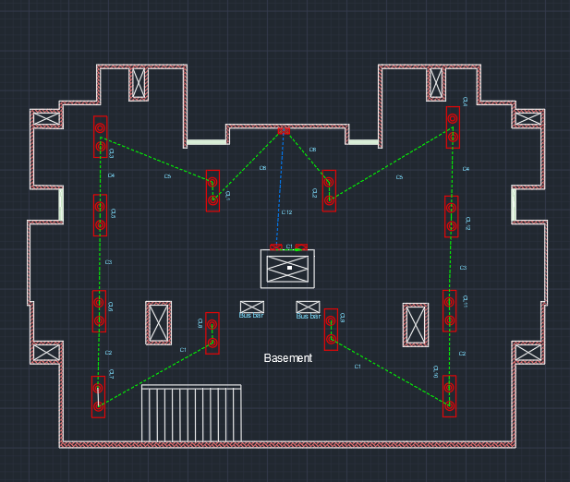

**Ground Floor**

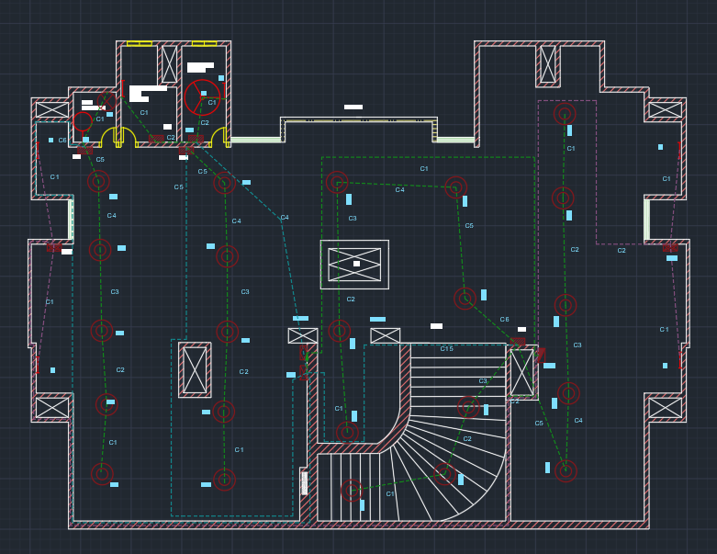

**Roof**

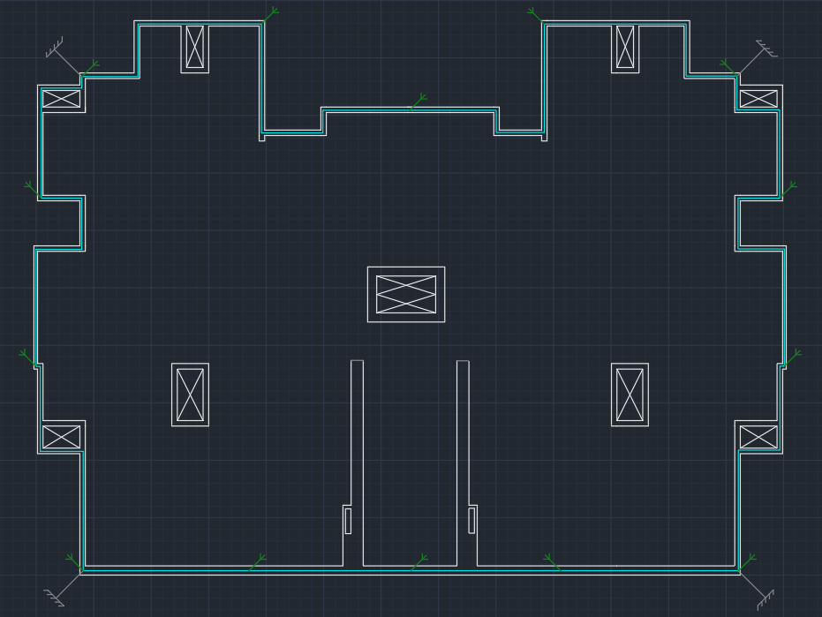

**First Floor**

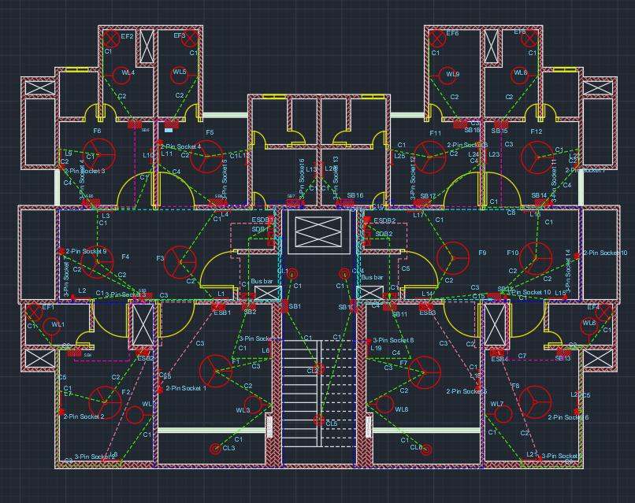

**Switch Board Diagrams**

**Basement**

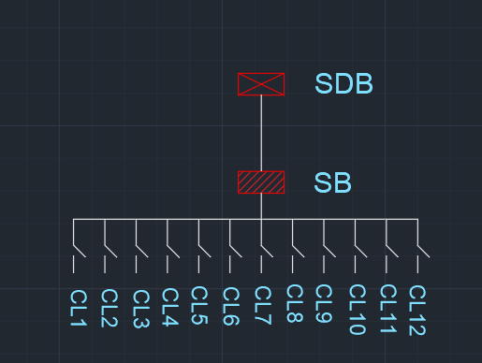

**Ground Floor**

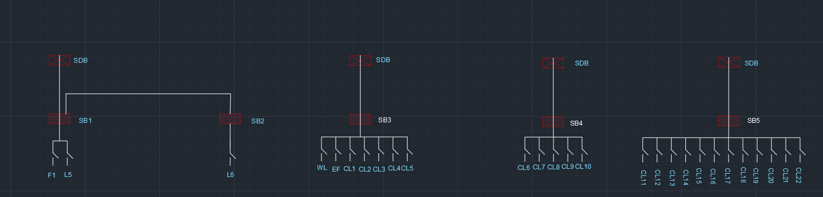

**First Floor**

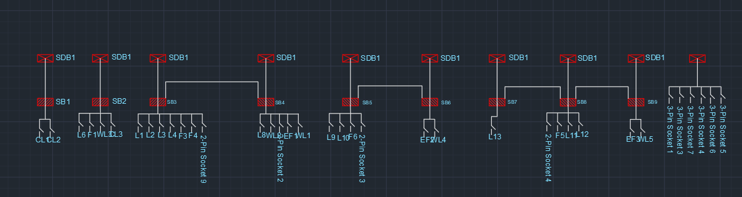

**Emergency Switch Board Diagrams**

**Ground Floor**

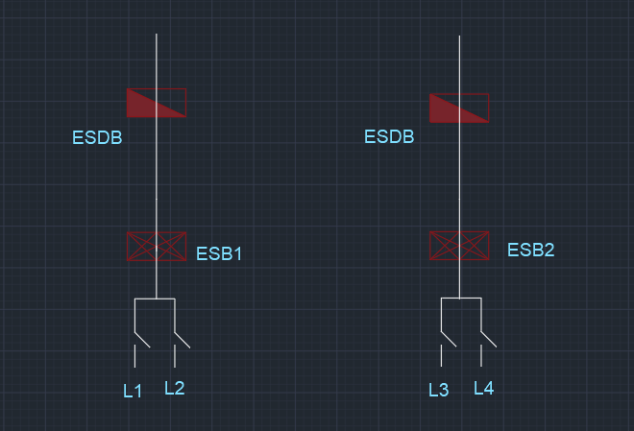

**First Floor**

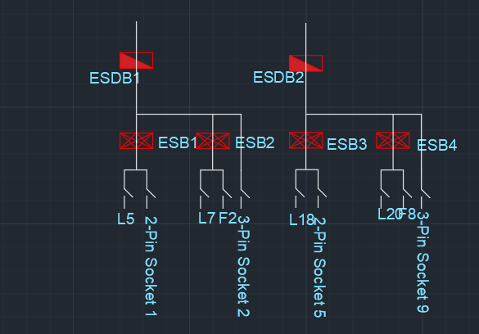

**Discussion**

The crossing of conduits in the drawing was avoided as much as possible. For the few crossings that may seem to occur, they can be passed through separate channels of varying length of the walls. Also, the customized conduits, C10, C11 & C15 are required due to load exceeding the conduit ratings provided in lab sheet. In case of these conduits, they comply with the conduit characteristic chart provided.